[Type a quote from the document or the summary of an interesting point. You can position the text box anywhere in the document. Use the Text Box Tools tab to change the formatting of the pull quote text box.]
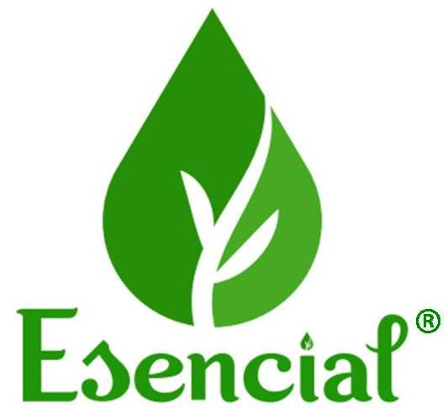

Co2 total Extract – Achillea Myllefolium

( wild flower )

Msds - Material safety data sheet
2019
esencial® ----- marks ,herbalist &Producer
Elbasan - Albania
-----------------------------------------------------------------------------------------------------------------------
1. PRODUCT NAME AND COMPANY IDENTIFICATION
1 - Product Name: CO₂ Total Extract Achillea Myllefolium ( wild flower )
2 - Product Use: Raw materials for industry
3 - Company Name: Esencial ®
4 - Company Address: Elbasan Labinot - Fushe Mengel /E 852 KM 2 Elbasan - LIbrazhd 2564
.Objekti NR 6673/1 .
5 - Loti # TOT 191024
6- Batch # 191125 - C
7 - Date Issued: 08/12/2019
-----------------------------------------------------------------------------------------------------------------------
2. COMPOSITION/INGREDIENT INFORMATION
1 - Ingredients: CO₂ Tota Extract Achillea Myllefolium ( wild flower )
2 - Name: CO2 Total Extract Achillea Myllefolium ( wild flower )
3 - Contains : Contains 100% CO2 Total extract from Achillea Myllefolium ( wild flower )
4 - Additional Information: No additional substance was added to the product
5 - Hazardous Components: None
6 - Synonyms & Trade names : None
7 - CAS - None
8 - EINECS -None

-----------------------------------------------------------------------------------------------------------------------
3. HAZARDS IDENTIFICATION
1 - Environmental Hazards: None known
2 - Human Health Hazards:
- Eye: Irritation may occur
- Skin: Irritation may occur
- Ingestion: Irritation may occur
- Inhalation: Irritation may occur
-----------------------------------------------------------------------------------------------------------------------
4. FIRST AID MEASURES
1 - Eyes: Flush with plenty of water or eye wash solution for 15 minutes. Get medical attention if irritation
persists.
2 - Skin: Wash with soap and water- get medical attention if irritation persists.
3 - Ingestion: Rinse mouth immediately and drink large quantities of water. Seek medical attention if large
quantity is consumed.
4 - Inhalation: Remove to fresh air. Seek medical attention if needed. Medical Conditions Generally
5 - Aggravated by Exposure: None known
-----------------------------------------------------------------------------------------------------------------------
5. FIRE FIGHTING MEASURES
1 - Extinguishing Media: Dry Chemical, Carbon Dioxide, Foam
2 - Special Firefighting Procedures: Cool containers exposed to flame with water
3 - Unusual Fire & Explosion Hazards:. If smoke clouds are created they are not dangerous to human
health
-----------------------------------------------------------------------------------------------------------------------
6. ACCIDENTAL RELEASE MEASURES (STEPS FOR SPILLS)
1 - Personal Protection: Avoid contact with skin and eyes, concentrated extracts should not be swallowed.
2 - Environmental Protection: Keep away from canalization, waterway, and groundwater.
3 - Methods for Cleaning Up: Remove mechanically, placing in appropriate containers for disposal.
-----------------------------------------------------------------------------------------------------------------------
7. HANDLING AND STORAGE
1 - Handling:
Safe Handling :. In case of damage to the inner packaging, put gloves on and dispose of the waste to
the container of organic food products.
2 - Storage:
Requirements for Storage Areas and Containers: Store in a cool, dry location, in a sealed container,
away from sunlight.
-----------------------------------------------------------------------------------------------------------------------
8. EXPOSURE CONTROL/PERSONAL PROTECTION
1 - Eye: Wear splash goggles.
2 - Skin/Body: Wear oil resistant gloves. Remove contaminated clothing.
3 - Respiratory: Do not breathe vapor/aerosol.
4 - Ventilation: Area should be well ventilated.
5 - Other: Evaluate need based on application.
6 - Work/Hygiene Practice: Normal work and hygiene practices
-----------------------------------------------------------------------------------------------------------------------
9. PHYSICAL AND CHEMICAL PROPERTIES
1 - Physical State: Solid
2 - Color: Brown
3 - Odor: Characteristic, herbal
4 - Density at 20℃: > 1.094 g/cm3 pycnometer
5 - Flash Point: > 130 ℃
6 - Boiling point : 115 ºC
7 - Melting point : 65°C
8 - Viscosity : Very high (total CO2 extract requires pre-use heat)
9 - Solubility : Soluble in oil vegetable / insoluble alcohol /, insoluble in water
10 - Water Reactive: No
11 -Solvent Content: No
11 - Auto-ignition :No
12 - Chemical abrasives :No
-----------------------------------------------------------------------------------------------------------------------
10. STABILITY AND REACTIVITY
1 - Stability: Stable
2 - Conditions to Avoid : Heat, open flame and sunlight
3 - Hazardous Decomposition or Byproducts : Impossible (co 2 extract total requires long chemical-
physic processes)
4 - Hazardous Polymerization : Will Not Occur
-----------------------------------------------------------------------------------------------------------------------
11. TOXICOLOGICAL INFORMATION
1 - Acute Toxicity : It is not possible to happen
2 - Carcinogenicity:It is not possible to happen
3 - Reproductive Toxicity: It is not possible to happen
4 - Mutagenicity: It is not possible to happen
-----------------------------------------------------------------------------------------------------------------------
12. ECOLOGICAL INFORMATION
1 - Ecotoxicity : No data for ecological evaluation available.
-----------------------------------------------------------------------------------------------------------------------
13. DISPOSAL CONSIDERATIONS
1 - Waste Disposal Methods: Do not put into sewer lines. Dispose of according to local,state and federal
regulations.
-----------------------------------------------------------------------------------------------------------------------
14. TRANSPORT INFORMATION
1 - UN number: There is no . Not included in the scope of application of dangerous goods By air
(IATA/ICAO)
2 - Transport Hazard class(es) -None
3 - IATA :Not dangerous goods
4 - Class/Division: Not restricted
5 - Label: None
6 - Proper Shiping Name : CO₂ Total Extract Achillea Myllefolium ( wild flower )
-----------------------------------------------------------------------------------------------------------------------
15. REGULATORY INFORMATION
1 - Not available
-----------------------------------------------------------------------------------------------------------------------
16. ADDITIONAL INFORMATION
1 - This information is provided for documentation purposes only.
2 - This product is not considered hazardous.
3 - The complete range of conditions or methods of use are beyond our control therefore we do not
assume any responsibility and expressly disclaim any liability for any use of this product. Information
contained herein is believed to be true and accurate however, all statements or suggestions are made
without warranty, expressed or implied, regarding accuracy of the information, the hazards connected
with the use of the material or the results to be obtained from the use thereof. Compliance with all
applicable federal, state, and local laws and local regulations remains the responsibility of the user.
4 - This safety sheet cannot cover all possible situations which the user may experience during
processing. Each aspect of your operation should be examined to determine if, or where, additional
precautions may be necessary. All health and safety information contained in this bulletin should be
provided to your employees or customers.
END OF MSD SHEET
-----------------------------------------------------------------------------------------------------------------------

REVISION DATE : 18/10/2019
Prepared By : Mrs Lindita Vrushi
Biochemistry in ESENCIAL
Signature------------------------------

